**Practical No 7**

**Show loading of 4 different advertisements using Adrotator control.**

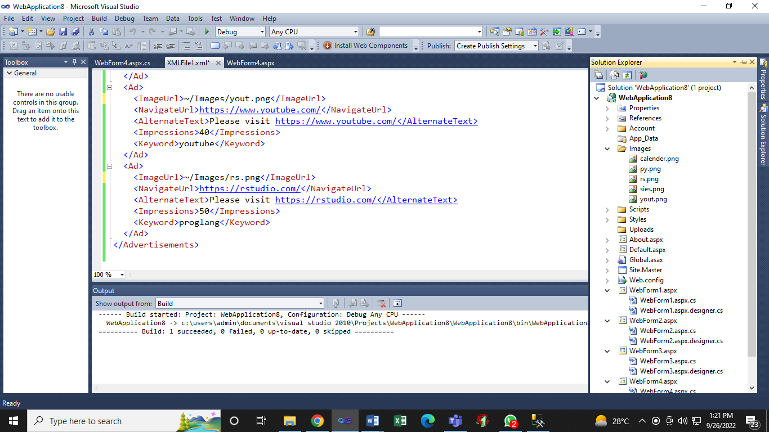

**XMLFile1.xml**

<?xml version="1.0" encoding="utf-8" ?>

<Advertisements>

<Ad>

<ImageUrl>~/Images/py.png</ImageUrl>

<NavigateUrl>https://www.python.org/</NavigateUrl>

<AlternateText>Please visit https://www.python.org/</AlternateText>

<Impressions>10</Impressions>

<Keyword>proglang</Keyword>

</Ad>

<Ad>

<ImageUrl>~/Images/sies.png</ImageUrl>

<NavigateUrl>http://siesascs.edu.in/</NavigateUrl>

<AlternateText>Please visit http://siesascs.edu.in/</AlternateText>

<Impressions>50</Impressions>

<Keyword>siesascs</Keyword>

</Ad>

<Ad>

<ImageUrl>~/Images/yout.png</ImageUrl>

<NavigateUrl>https://www.youtube.com/</NavigateUrl>

<AlternateText>Please visit https://www.youtube.com/</AlternateText>

<Impressions>40</Impressions>

<Keyword>youtube</Keyword>

</Ad>

<Ad>

<ImageUrl>~/Images/r.png</ImageUrl>

<NavigateUrl>https://rstudio.com/</NavigateUrl>

<AlternateText>Please visit https://rstudio.com/</AlternateText>

<Impressions>50</Impressions>

<Keyword>proglang</Keyword>

</Ad>

</Advertisements>

**.aspx**

<%@ Page Language="C#" AutoEventWireup="true" CodeBehind="WebForm4.aspx.cs" Inherits="WebApplication8.WebForm4" %>

<!DOCTYPE html PUBLIC "-//W3C//DTD XHTML 1.0 Transitional//EN" "http://www.w3.org/TR/xhtml1/DTD/xhtml1-transitional.dtd">

<html xmlns="http://www.w3.org/1999/xhtml">

<head runat="server">

<title></title>

</head>

<body>

<form id="form1" runat="server">

<div>

<asp:AdRotator ID="AdRotator1" AdvertisementFile="~/XMLFile1.xml" Target="_blank" runat="server" />

</div>

</form>

</body>

</html>

**.cs**

using System;

using System.Collections.Generic;

using System.Linq;

using System.Web;

using System.Web.UI;

using System.Web.UI.WebControls;

namespace WebApplication8

{

public partial class WebForm4 : System.Web.UI.Page

{

protected void Page_Load(object sender, EventArgs e)

{

AdRotator1. KeywordFilter = "proglang";

}

}

}

**Output**

Click the refresh button to see different advertisements. Notice the tabs that are open here.

